**NAME: ALI GHULAM MURTAZA**

**ROLL NO: SFI-24S-001**

**LAB NO: 5**

**TASK NO 1: Basic Task: Write a program that checks if a given number is positive, negative, or zero.**

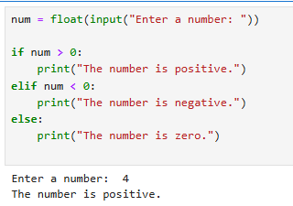

**TASK NO 2: Intermediate Task: Write a program that takes user input and determines whether it's a even or odd.**

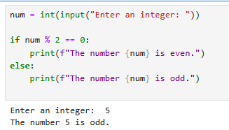

**TASK NO 3: Create a program that asks user to print:**

* **"Excellent" if marks are above 80**
* **"Good" if marks are between 60 and 80**
* **"Needs Improvement" if marks are below 60**

